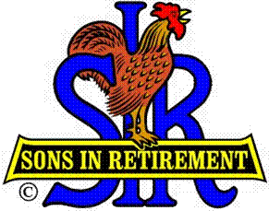

Las Trampas Branch 116

Luncheon Meeting Agenda

February 20, 2017

11:30 AM
- Call to Order – Big Sir.
- Welcome
- Pledge of Allegiance.
- Invocation: Matt Arena
- Introduce Head Table
- Little Sir: Marty Katz
- Chaplin: Matt Arena
- Guest Speaker – Jeff Lynch
- Introduce Guests & Visitors
- Guests:
- Visitors:
- Induct New Members (if any)
- Big Sir Comments:
- Boundary Oak Voting
- Sunshine Report – Matt Arena
- Marty Katz – Storyteller

11:45 PM – Lunch

12:15 PM
- Committee Reports

12:30 PM
Little Sir:
- Introduce Guest Speaker – Jeff Lynch
- Raffle Drawing
- Ask February Birthday guys to stand / sing Happy Birthday (Paul King & Robbie)
- Drawing for Free Lunch.
- Sign God Bless America.

